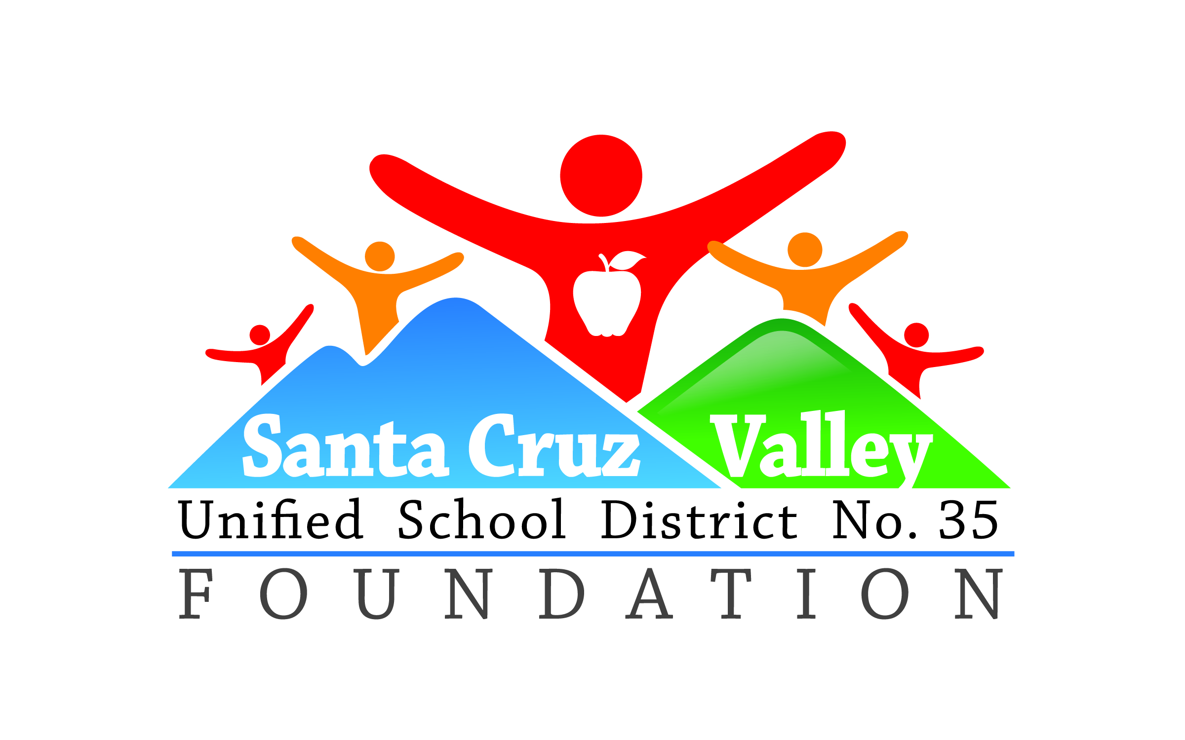
Friends of Santa Cruz Valley USD #35 Present
“The Benchmark Foundation of Tubac and the Tubac Golf Resort and Spa Recognition of Excellence Award”

Application Form

The purpose of this award is to support an outstanding educator from Santa Cruz Valley Unified School district in his/her desire to enhance subject area knowledge, to add additional certifications, or to support personal growth. The dollars available to the Foundation for this effort have been provided by The Benchmark Foundation of Tubac and the Tubac Golf Resort and Spa.

Teacher Name_______________________________________________________________

Current Position ____________________________________________________________

Current certifications ______________________________________________________

______________________________________________________

______________________________________________________

Where will you pursue the coursework?

Aspirations - What will you do with the coursework if selected? (i.e. become special education certified, add an endorsement, pursue administrative certification?

How will this additional coursework enhance your classroom instruction (if so how)?

If you are pursuing an administrative certification, what are your goals?

Why should we select you for this award?

This application is also available online at www.friendsofdistrict35.org. The deadline for submission of your application is May 24, 2019. It may be returned to your principal or it can be submitted to azbazzoteach@yahoo.com. You will be notified by June 30, 2019 if you are selected for this award.

